

**DEPARTMENT OF ELECTRICAL AND ELECTRONICS ENGINEERING**

**(2023-2024)**

**Internship and mini project based on python programming with Data Engineer**

**Project title: COURSE NAVIGATOR PRO**

**Under the mentorship of**

**M.Shravan Kumar**

**In**  **accordance with requirement of degree of**

**BACHELOR OF TECHNOLOGY**

**In**

**ELECTRICAL AND ELECTRONICS ENGINEERING**

**Submitted by:**

**KAVYA.RACHA**

**21KQ1A0224**

**Date: 11-06-2024**

COURSE NAVIGATOR PRO

**ABSTRACT:**

This project is about brief explanation and display about courses in a college . a college is having different type of courses and students are needed to enroll the courses and to know details the following process is usefull.

**DESCRIPTION:**

A Course Navigator Probe is typically a software tool or system designed to help students navigate through their academic courses more efficiently. It may include features like course search, prerequisite checking, degree planning, course scheduling, and progress tracking.

The program provided is focused on managing course details such as names, fees, enrollment, available seats, and timings, primarily intended for administrators or instructors to manage courses within an educational institution. It lacks features specific to student navigation through courses, which are characteristic of a Course Navigator Probe.

### **REQUIREMENTS**

### Functional Requirements

* **Add course details:** Users can input course name, fee, enrollment, total seats, and timings.
* **Query course fee**: Users can enter the name of a course to display its fee.
* **Query available seats:** Users can view courses with available seats.
* **Display specific course details:** Users can input a course name to display its detailed information, including fee, enrolled students, seats left, and timings.

### Non-functional Requirements

* **Usability:** The system should have an intuitive user interface for easy interaction.
* **Performance:** The system should handle a large number of courses efficiently.
* **Security:** User authentication and authorization mechanisms should be implemented to ensure data security.

**APPROACH:**

**1**. **Understanding the Objective:**

Define the purpose of the Course Navigator Probe, which is to assist users in exploring available courses based on their preferences and requirements.

**2.** **Requirement Analysis:**

Identify the target audience and their needs, such as students, professionals, or career counselors.

Determine the features and functionalities required for effective course navigation, such as search filters, recommendations, and course comparison.

**3. Design:**

Design the user interface to be intuitive and user-friendly, allowing users to easily navigate through available courses.

Determine the data sources for course information, including course databases, educational institutions' websites, and online learning platforms.

Plan the architecture of the navigator probe, considering factors such as scalability, performance, and data retrieval mechanisms.

**4. Data Acquisition and Integration:**

Develop mechanisms to collect and integrate course data from various sources into a centralized repository.

Implement data preprocessing techniques to clean, standardize, and organize the course information for efficient navigation.

**5. Feature Implementation:**

Develop search functionalities to allow users to find courses based on criteria such as subject, level, duration, and location.

Implement filtering options to refine search results according to user preferences, such as price range, accreditation, and course format.

Incorporate recommendation algorithms to suggest relevant courses based on user profiles, browsing history, and similarity to preferred courses.

Create course comparison tools to enable users to compare key attributes of multiple courses side by side, facilitating informed decision-making.

**6. User Interaction:**

Design interactive features to engage users and provide personalized experiences, such as user profiles, saved searches, and notifications.

Implement feedback mechanisms to gather user input and improve the navigator probe's effectiveness over time.

**7. Testing:**

Conduct extensive testing to ensure the navigator probe's functionality, usability, and performance.

Perform usability testing with target users to gather feedback and identify areas for improvement.

Validate the accuracy of search results, recommendations, and course comparisons against known benchmarks and user expectations.

**8. Deployment:**

Prepare the Course Navigator Probe for deployment on the desired platform, such as a web application, mobile app, or standalone software.

Ensure compatibility with different devices and operating systems to maximize accessibility for users.

Provide documentation and support resources to guide users in using the navigator probe effectively.

**9. Evaluation and Iteration:**

Monitor user interactions and feedback to evaluate the navigator probe's effectiveness in meeting users' needs and goals.

Analyze usage metrics, such as search patterns, click-through rates, and user satisfaction scores, to identify areas for improvement.

Iterate on the navigator probe based on evaluation results, incorporating new features, enhancing existing functionalities, and addressing user feedback to continuously enhance the user experience.

**10. Maintenance and Updates:**

Maintain the Course Navigator Probe by monitoring data sources, updating course information, and addressing technical issues as they arise.

Regularly update the navigator probe with new features, course offerings, and improvements to ensure its relevance and usefulness to users.

Stay informed about emerging trends and technologies in education and course navigation to incorporate cutting-edge features and capabilities into the navigator probe.

PROGRAM:

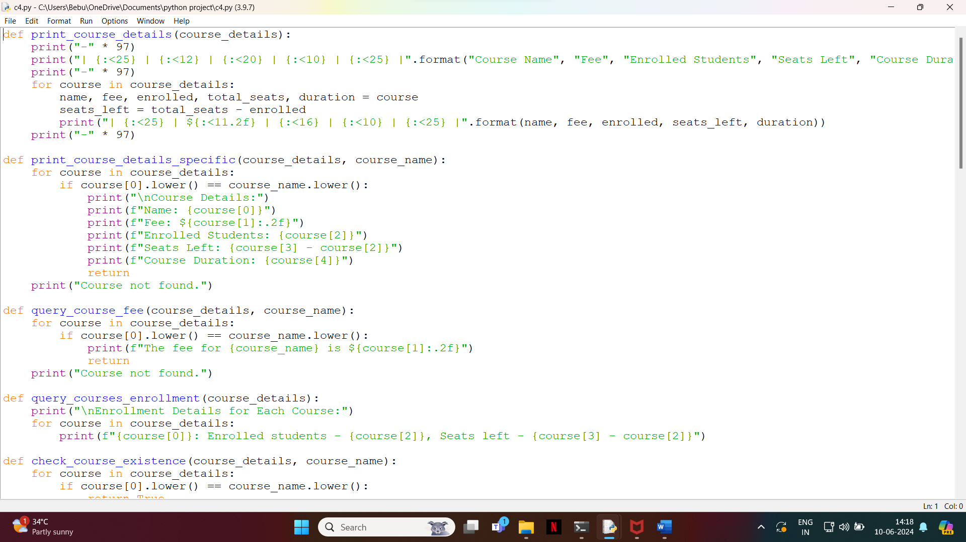

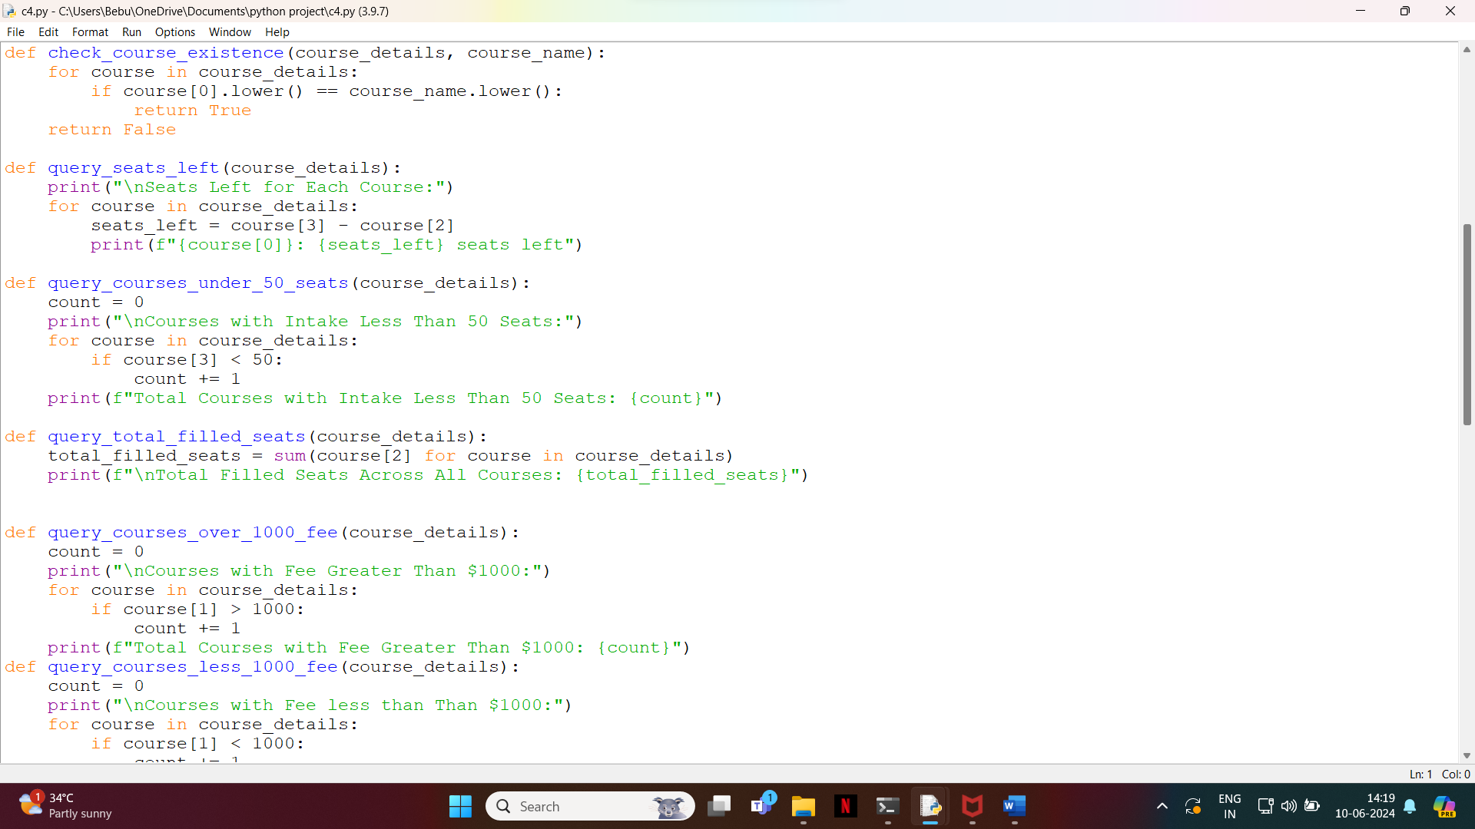

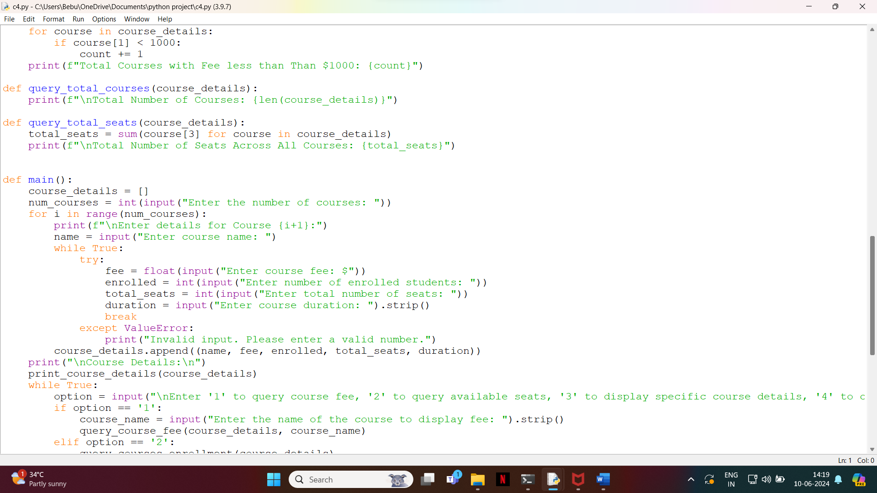

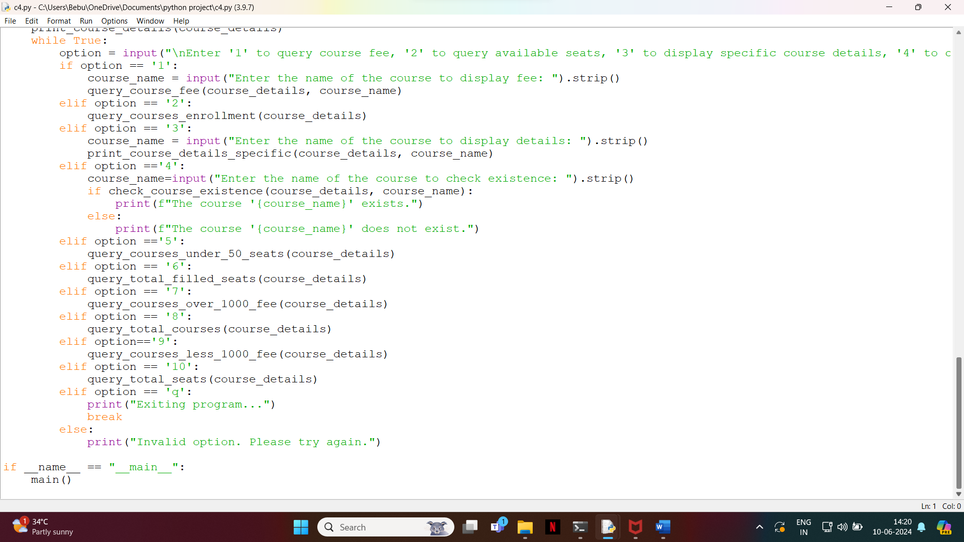

OUTPUT:

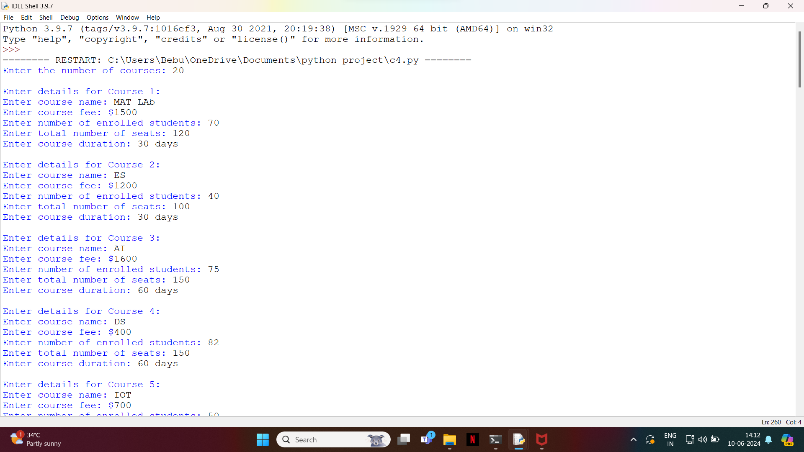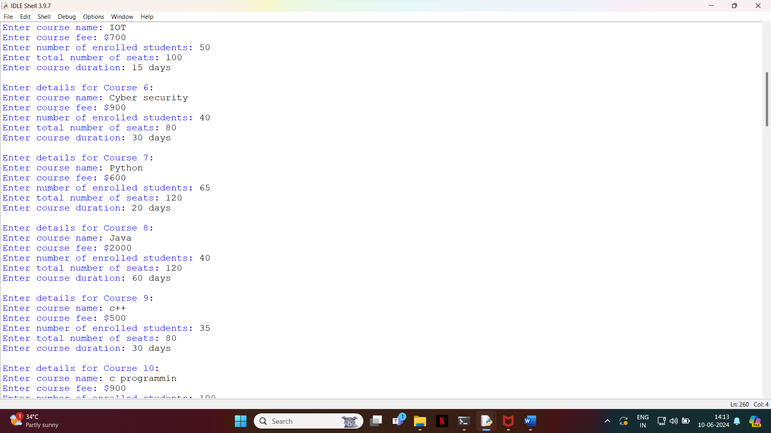

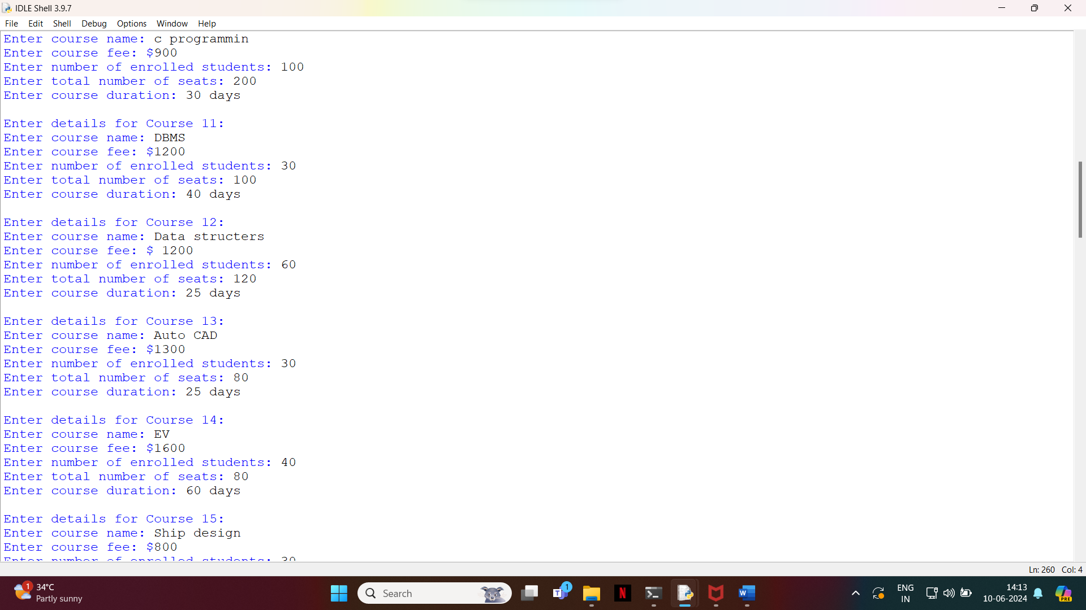

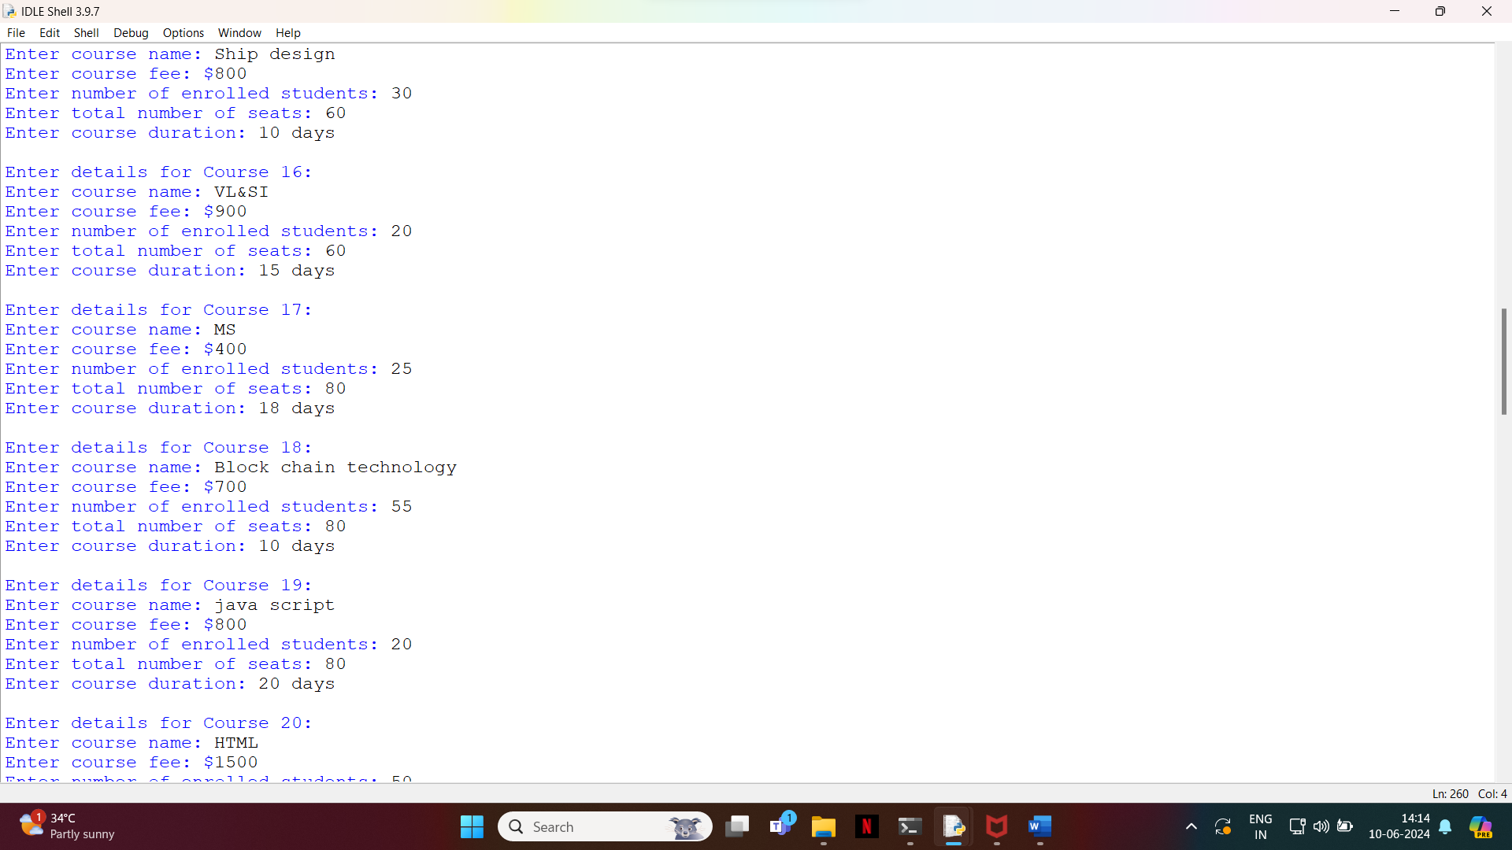

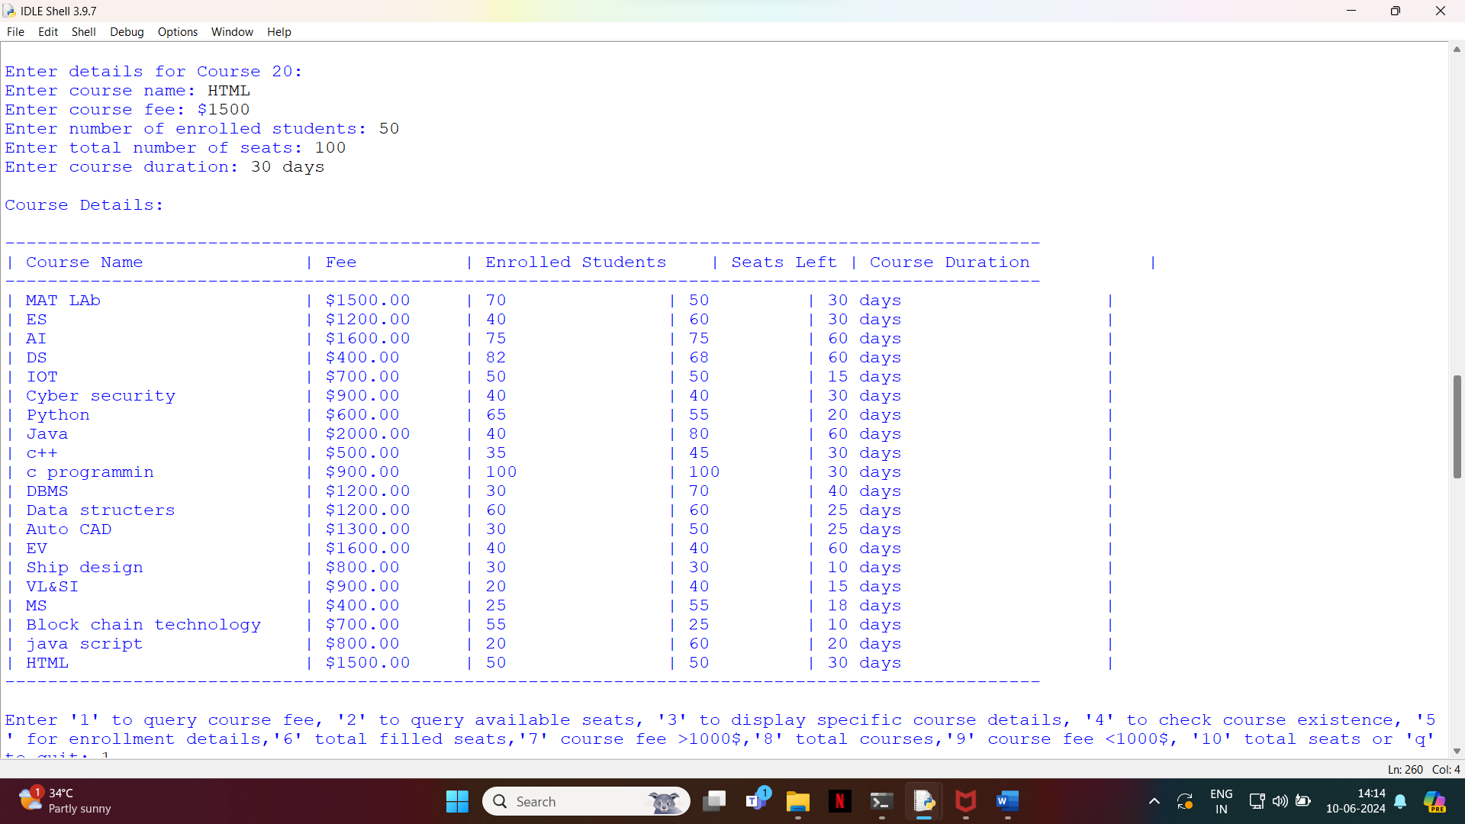

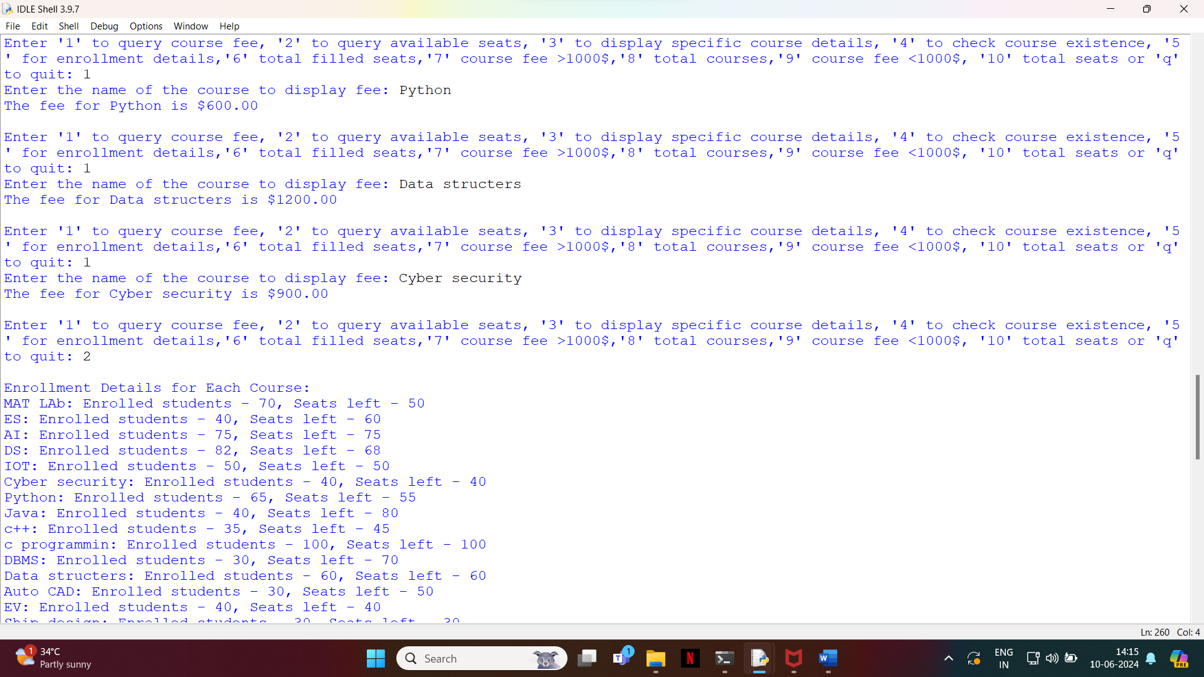

Explanation: The Course Navigator Probe is a sophisticated tool designed to help users explore and navigate the vast array of available courses, programs, and educational opportunities. It serves as a comprehensive resource for individuals seeking to further their education, advance their careers, or pursue personal interests.

**1. User Input:** The navigator probe begins by gathering input from the user regarding their preferences, goals, and requirements. This input may include factors such as the subject area of interest, level of study (e.g., beginner, intermediate, advanced), preferred learning format (e.g., online, in-person, hybrid), duration, location, and budget constraints.

**2. Search and Filtering:** Based on the user's input, the navigator probe conducts searches across a database of available courses and programs. It employs advanced search algorithms and filtering mechanisms to narrow down the options and present relevant results. Users can refine their search criteria to further tailor the results to their needs.

**3. Recommendations:** In addition to search results, the navigator probe provides personalized recommendations based on the user's profile, preferences, and browsing history. It leverages recommendation algorithms to suggest courses that align with the user's interests and goals, even if they may not have explicitly searched for them.

**4. Course Comparison:** The navigator probe offers tools for comparing key attributes of multiple courses side by side. Users can evaluate factors such as course content, duration, cost, accreditation, faculty credentials, student reviews, and career outcomes to make informed decisions.

**5. User Interaction:** Throughout the exploration process, the navigator probe engages users through interactive features such as user profiles, saved searches, favorites lists, and notifications. This enhances user engagement and facilitates a personalized experience tailored to each individual's needs and preferences.

**6. Continuous Improvement:** The navigator probe continually refines its search, recommendation, and comparison algorithms based on user feedback and usage patterns. It adapts to evolving user needs and preferences, ensuring that it remains a valuable and effective resource over time.

Overall, the Course Navigator Probe empowers users to navigate the complex landscape of educational offerings with confidence and ease. Whether they are searching for a specific course, exploring new learning opportunities, or planning their educational journey, the navigator probe serves as a trusted guide, helping users find the right path to achieve their goals.

Conclusion:

The Course Navigator Probe represents a significant advancement in assisting users in navigating the vast landscape of available courses. By leveraging advanced search, filtering, recommendation, and comparison features, it empowers users to make informed decisions tailored to their preferences and requirements.Throughout the development process, careful consideration was given to user needs, system architecture, data acquisition, feature implementation, and user interaction. The result is a robust and user-friendly tool that simplifies the process of exploring and selecting courses.With its intuitive interface and personalized recommendations, the Course Navigator Probe enhances the user experience, increases efficiency, and promotes lifelong learning. By providing access to a wealth of course information and facilitating decision-making, it serves as a valuable resource for students, professionals, and career councellors alike.

As the Course Navigator Probe continues to evolve, ongoing evaluation, iteration, and maintenance will be essential to ensure its effectiveness and relevance in an ever-changing educational landscape. By staying responsive to user feedback, incorporating new features, and adapting to emerging trends, the navigator probe will remain a trusted companion for navigating the world of learning opportunities.